**Home page**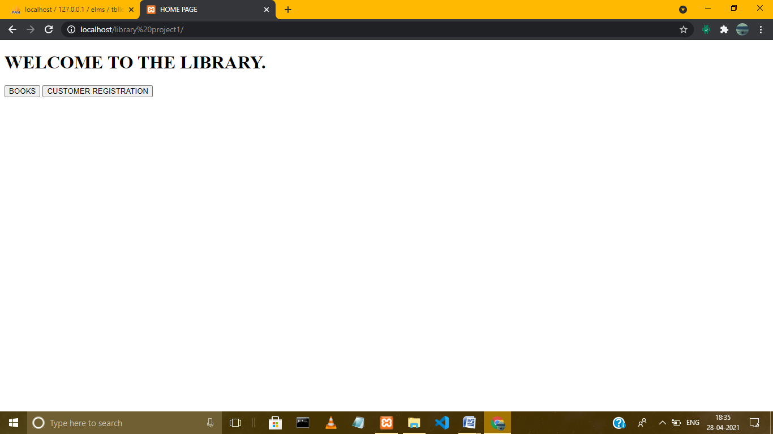

**Customer registration page:**

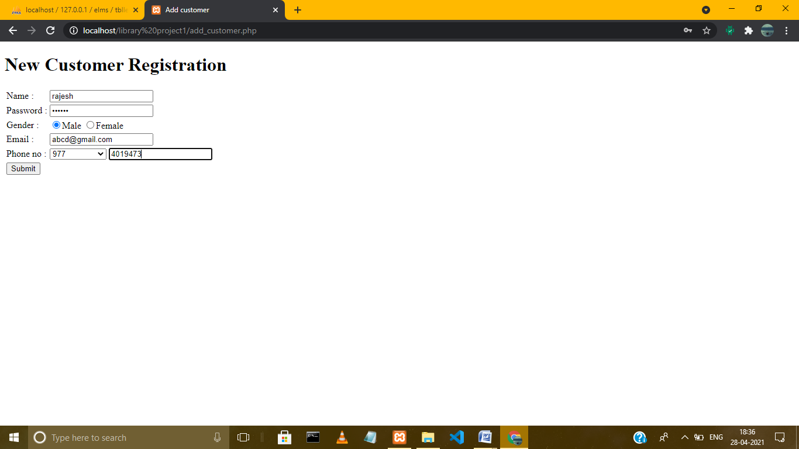

**After registration:**

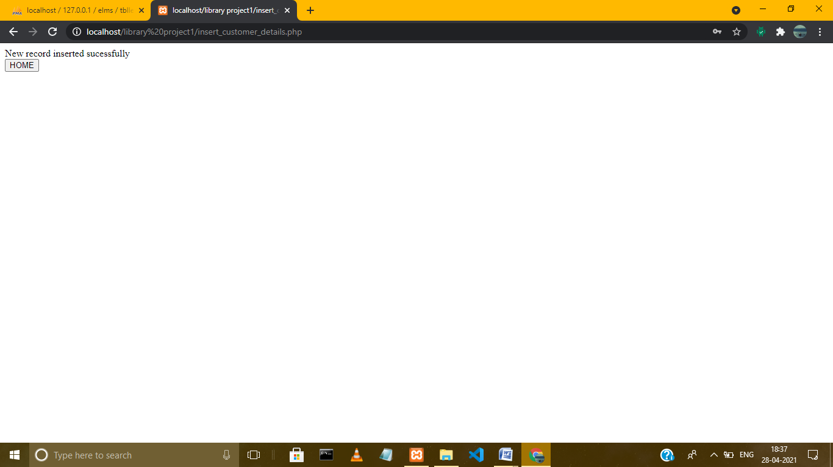

**After click the book button the home page:**

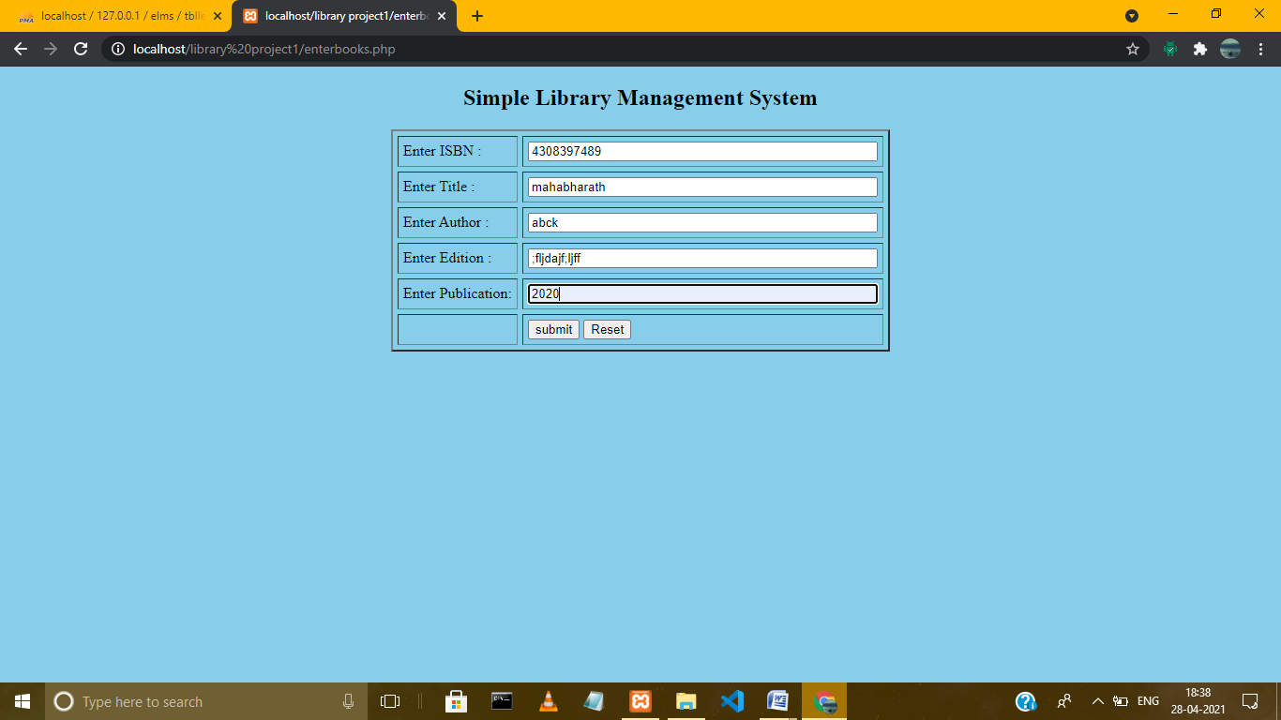

**After submit all details in the above picture:**

**Search book screen:**

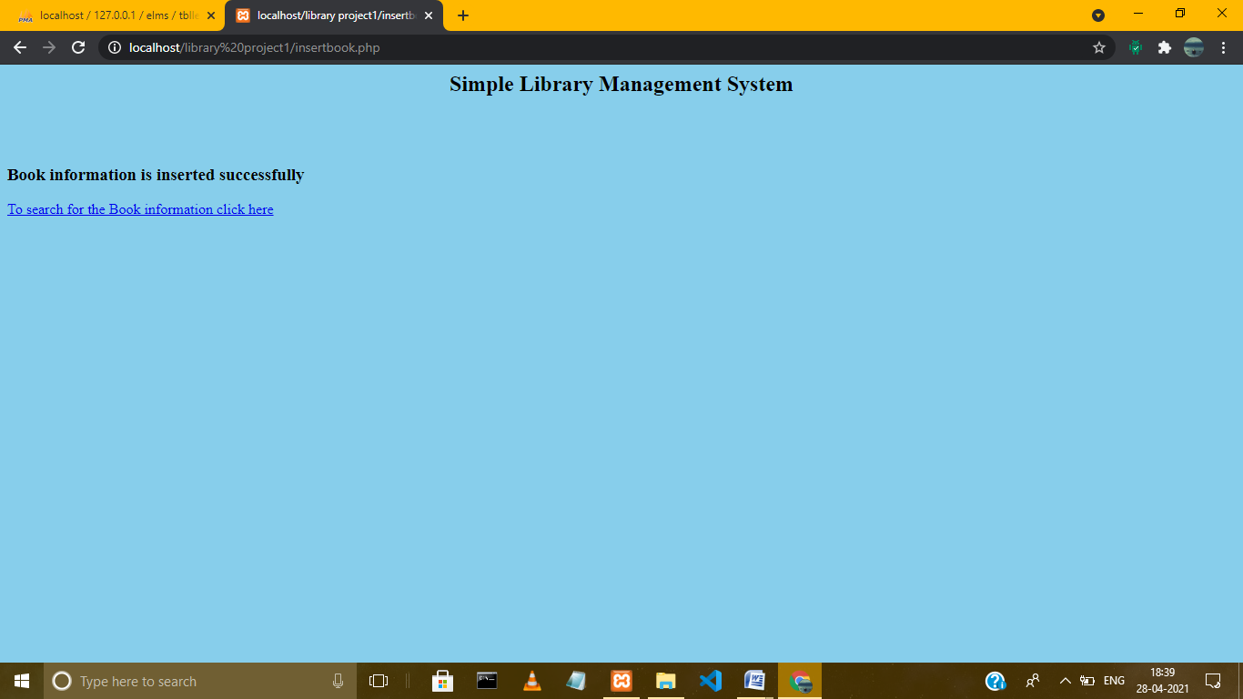

**After click the link:**

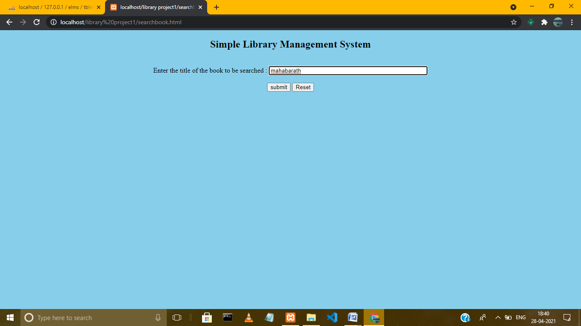

**After give book name:**

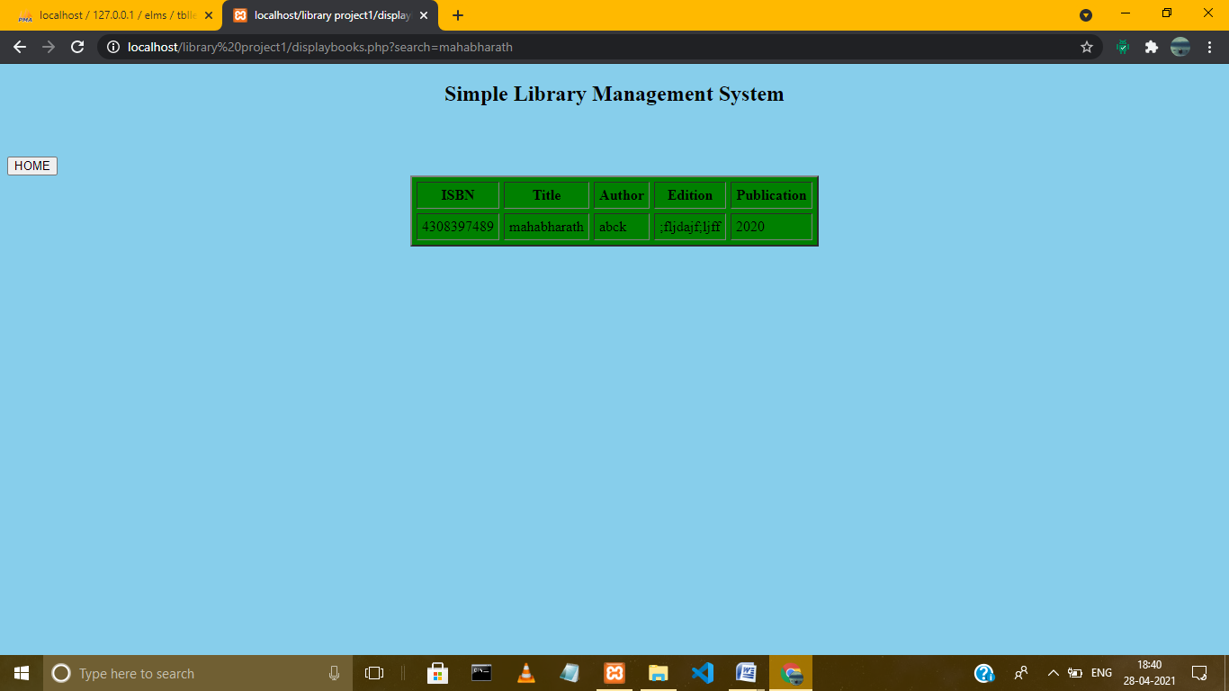

**That’s all**

**\*\*\*\*\*\*\*\*\*\*\*\*\*\*\*\*\*\*\*\*\*\*\*\*\*\*\*\*\*\*\*\*\*\*\*\*\*\*\*\*\*\*\*\*\*\***